Ideation Phase
Empathize & Discover

Date | 05 December 2025
Project Name | FlightHub - Flight Booking Application
Maximum Marks | 4 Marks

Empathy Map Canvas:
Understand the needs, motivations, frustrations, and booking behaviors of travelers as they search for flights, compare prices, choose travel preferences, and complete flight reservations on online platforms.

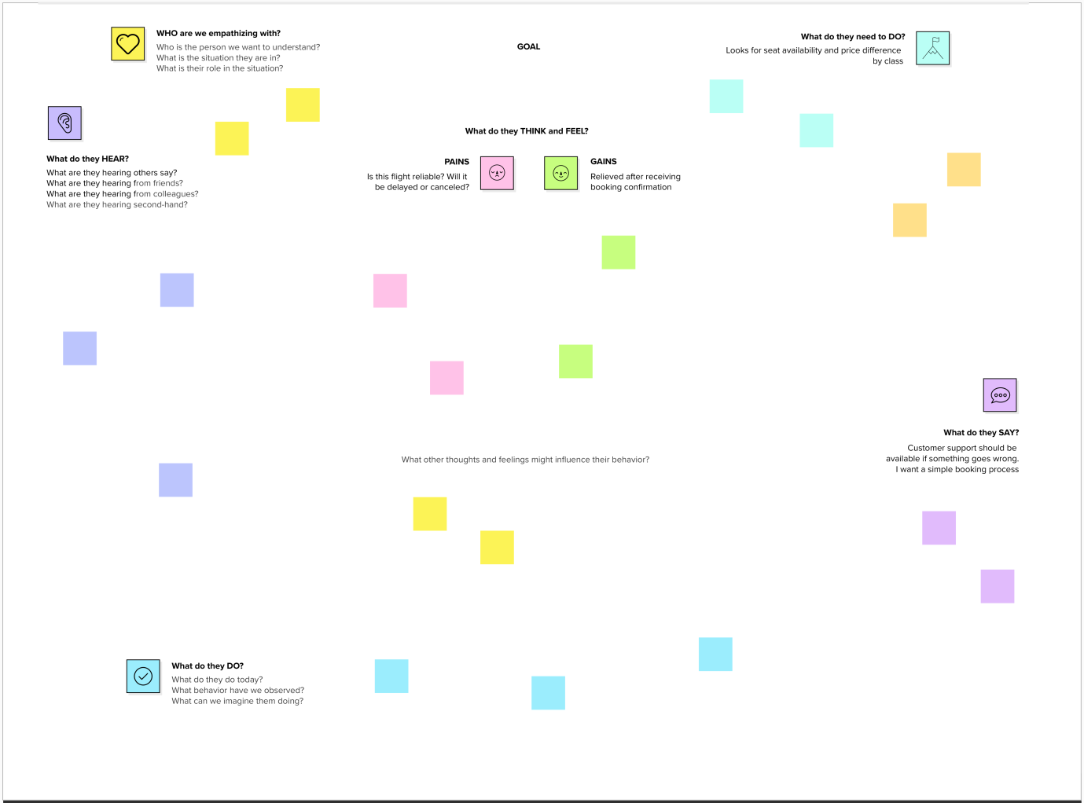

Users need a simple and trustworthy platform to search, compare, and book flights quickly while feeling confident about price transparency, payment security, and booking confirmation.

